# Agile Analytics

## Instructions & Template for Peer-Reviewed Assignment

# NOTE: Go to the ‘File’ menu and then use either ‘Make a copy’ or ‘Download As’ to make yourself an editable copy of this template.

# What am I doing?

## Overview

For this assignment, you’ll be developing:

1. Project description
2. Demand/value hypothesis
3. User stories
4. Analytical questions and metrics to answer those questions

## Instructions

Also, as you go through these, you may want to delete the **Intro Note** and **Instructions** sections in your copy. (In Google Docs, right-click (or two-finger click on Mac) and select ‘Delete Table’.)

# 

# Part 1: Positioning Statement

## Intro Note

If you’re in the specialization, I recommend picking a concept you can build up through the courses. For example, you might have an idea to solve a problem (job, desire) you’ve had or seen, or you might want to focus on something at your current job.  ***Regardless, it's most important that the idea is relatively specific (vs. perfect) and that it’s okay for you to share it with your peer reviewers.***

## Instructions & Example

|  |
| --- |
| For your product concept, just state what it does in the format you see below in ‘Assignment’. As obvious as it may seem, I find this helps with focus and collaboration- it will also help your peer reviewers better understand the balance of your assignment.  For an example, please see Appendix 1/Positioning Statement. |

## Assignment

Introduce your the company whose product you’re working on with the positioning statement structured as follows [fill in the brackets]:

For **Data analysts and business decision-makers** who **need to extract meaningful insights from large datasets efficiently**, the **Agile Analytics Platform is a data analytics solution** that **enables teams to apply agile methodologies to data-driven projects, allowing iterative development and continuous improvement**. Unlike **traditional data analysis methods that require lengthy development cycles**, our **product provides a flexible, incremental approach to data analytics that quickly adapts to changing business needs.**

## 

# Part 2: Sketch a Demand/Value Hypothesis

## Intro Note & Examples

In this section, you’ll explicitly define a demand/value hypothesis, making sure that it links back to a clear problem scenario/job-to-be-done and alternative. I’ve included examples from the HVAC in a Hurry in the appendix. Here’s an example for this section: Part 2: Sketch a Demand/Value Hypothesis.

Note: If you’re in the specialization and you have drafted a value/demand hypothesis in one of the other courses, feel free to use that here.

## Instructions

There are three rows in the template, but for the assignment you only need to complete *one*.

Note: If you’re in the specialization and you have drafted problem scenarios, etc. in one of the other courses, feel free to use those here.

## Assignment Body

|  |  |  |
| --- | --- | --- |
| **Problem Scenarios/Jobs-to-be-Done** | **Current Alternatives** | **Your Demand/Value Hypothesis** |
| [ADD- What fundamental job/problem/habit does the persona have in your area?] | [ADD- Instead of using your product or feature, what do they do right now to solve this delivery on the underlying job/problem?] | [ADD- What might you do that’s better enough than the leading Alternative at delivering on the PS/JTBD? Make sure to render this in this testable form--  If we [do x] for [y customer] then they will [respond in z way].  ] |
| Data teams struggle with long feedback loops, causing delays in insights generation. | Teams rely on traditional waterfall analytics approaches, which are rigid and slow to adapt. | If we introduce an agile analytics framework, then teams will be able to iterate on data analysis faster and improve decision-making. |
| Business users require real-time insights but often face bottlenecks in accessing data. | They depend on IT or data engineers to prepare and deliver reports, which slows down decision-making. | If we provide a self-service analytics tool, then business users will access insights independently, reducing dependencies on technical teams. |

# Part 3: Design a Testable Solution for Your Value/Demand Hypothesis

## Intro Note

In this section, you’ll sketch one or more epics, then pick one of them to detail and instrument with analytics. For the epic you detail, you’ll identify a ‘dependent variable’ that answers the question ‘How do we know if this implementation is working for the user?’. From there, you’ll work out how you might observe this in steps and what ‘independent variables’ would help with your analysis there.

Note: As always, feel free to use work from previous courses. Also, there isn’t a section here for a storyboard in the epics, but if you have that, I recommend including it to better articulate the epic.

## Example

See Appendix 1/Part 3 for an example.

## Epic User Stories

[Epic 1 in format “As a [persona],I want to [do something] so that I can [realize a reward]”]

[Epic 2 in same format]

…

[Epic N in same format]

#### ****Epic User Stories****

* ****Epic 1**: As a **data analyst**, I want to **create and update dashboards iteratively** so that I can **quickly adapt to business changes**.**
* ****Epic 2**: As a **business user**, I want to **access real-time data insights** so that I can **make informed decisions without waiting for reports**.**
* ****Epic 3**: As a **data engineer**, I want to **automate data pipeline updates** so that I can **support analytics needs without manual intervention**.**

## Epic 1- Detail

### Dependent Variable/Goal for Epic 1

[Answer the following questions: What are the most important analytical questions for the epic as a whole? How will you know if the user is getting what you intended out of the interaction? What specific observations (the fewer the better) do you need to make to measure this? ]

### Child Stories & Analytics for Epic 1

Note: If you’re in the specialization, the metrics for the child stories were previously optional. Below, add metrics that are actionable and detail how you might implement those metrics.

#### ****Epic 1 - Detail****

****Dependent Variable/Goal for Epic 1****

* **How frequently do users update dashboards?**
* **Does iteration speed improve insights delivery?**
* **Are business users making data-driven decisions faster?**

|  |  |  |
| --- | --- | --- |
| **Child Stories** | **Analytical Question(s)** | **Analytics** |
| I want to create a dashboard with minimal setup so I can start analyzing data quickly. | How many dashboards are created per user per month? | Count of new dashboard creations. |
| I want to receive automated suggestions for dashboard improvements based on usage patterns. | How often do users adopt suggested changes? | Adoption rate of suggested changes. |
| I want to share dashboards easily with my team for collaboration. | How frequently are dashboards shared? | Number of shared dashboards per user. |
| I want to integrate external data sources to enrich analysis. | How often are external sources connected? | Number of external integrations per dashboard. |

# Submitting Your Assignment

Remember to upload your work in ONE document (PDF format).

# 

# Appendix 1: Reference Example

## Part 1: Positioning Statement

### Intro Note

I’ve included a positioning statement for both the enterprise as a whole and the specific (internal) product the HinH team is working. I thought this enterprise statement would help with context/relevance for the product. Including a positioning statement for the enterprise/company as a whole is optional, though.

### For the Enterprise as a Whole

For [facilities managers & business owners] who [need their heating & cooling systems managed and repaired], [HVAC in a Hurry] is a [full service heating and cooling provider] that [allows for easy and responsible management of a business’ HVAC systems]. Unlike [smaller firms], our [commitment to best practices and training allows customers to worry less and realize superior total cost of ownership for their HVAC systems].

### 

### For their Digital Platform

For [dispatchers and technicians] who [work at HVAC in a Hurry], [H-ify] is an [enterprise software solution] that [improves the HVAC repair and maintenance experience for both internal staff and customers]. Unlike [ad hoc solutions], our product [has been carefully formulated and validated against best practices and awesome customer experiences out in the field].

## Part 2: Sketch a Demand/Value Hypothesis

|  |  |  |
| --- | --- | --- |
| **Problem Scenarios/Jobs-to-be-Done** | **Current Alternatives** | **Demand/Value Hypothesis** |
| Getting replacement parts to a job site  Engagement Metric  [Parts Ordered/Period] | Call the office and request the part then wait for an update on the phone or through a call-back | If we automate parts lookup and ordering online, then the tech’s will use it and it will improve outcomes. |

## Part 3: Design a Testable Solution for Your Value/Demand Hypothesis

### Epic User Stories

**‘As Ted the HVAC technician, I want to know the pricing and availability of a part that needs replacing so I can decide my next steps.’**

As Ted the HVAC tech, I want to order a replacement part so I can make sure I know my next steps and timing.

‘As Ted the HVAC tech, I want to understand how to arrive at my next job prepared so I avoid logistical delays and the customer having to repeat themselves.’

‘As Danielle the Dispatcher, I want to understand a customer’s location, needs, and urgency level so I can decide who, what, and when to dispatch to their site.’

‘As Danielle the Dispatcher, I want to see a specific technician’s availability so I can decide whether I’m able to use them for follow-up on a job they started.’

### Epic 1

Epic 1 is: ‘As Ted the HVAC technician, I want to know the pricing and availability of a part that needs replacing so I can decide my next steps.’

Please note:

a) The storyboard is **optional**

b) This was created with a tool, but a simple pencil/paper drawing is *fine*.

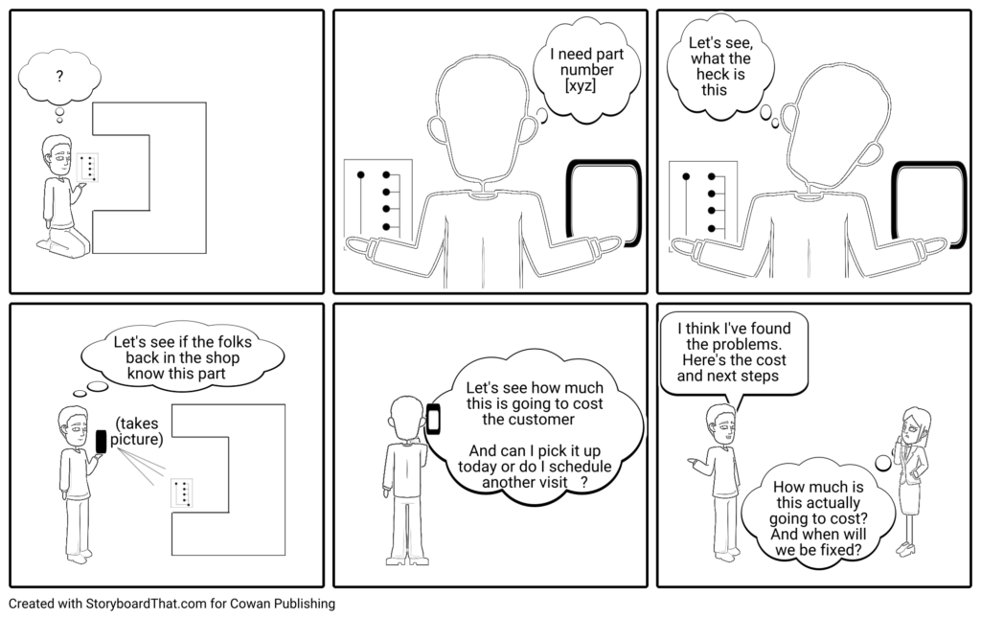

### Dependent Variable/Goal for Epic 1

The key questions here are--

a) Do the technicians use the tool to a) look up pricing and availability and/or b) place part orders?

b) Does that make them more productive?

The specific dependent variables for this, observations we might instrument into code and Google Analytics are:

a) Views of parts detail + availability detail/specific result pages

b) Orders

Also, customer satisfaction/job and billable/non-billable time for a cohort that uses the tool vs. doesn’t would be relevant.

### Child Stories & Analytics

|  |  |  |
| --- | --- | --- |
| **Child Stories** | **Analytical Question(s)** | **Analytics** |
| I know the part number and I want to find it on the system so I can find out its price and availability. | How often is this search used per transaction relative to the alternatives?  How often does this search lead to a part order? | Metrics:  - Searches of this type relative to others  - Sequence of this search relative to other search types  - Conversion to order from this type of search (%) |
| I don’t know the part number and I want to try to identify it online so I can find out its price and availability. |  | (see above) |
| I don’t know the part number and I can’t determine it and I want help so I can find out its price and availability. |  | (see above) |
| I want to see the pricing and availability of the part so I decide on next steps and get agreement from the customer. | How often does this lead to a part order?  How well do techs that do this perform relative to others? | Metrics:  Conversion rate to order  Customer satisfaction per job of tech’s in a cohort that use the tool vs. baseline (mean customer satisfaction per job)  Billable hours for tech’s in this cohort vs. baseline (billable hours per week) |